Unit 6 Website Development

Assignment 1

Oliver Collins-Cope

2022

Table of Contents

Introduction 2

Facebook 3

Usability 4

Consistency 6

Accessibility 7

Layout 10

Readability 11

Navigation 12

Typography 13

Bibliography 15

# Introduction

Throughout this assignment I will be discussing two different websites, Facebook and Twitter, and describing how they differ, comparing them based on different points such as usability, layout, navigation, content, readability, typography, accessibility, consistency and more. These sites will be compared, analysed, and evaluated in order to determine how well they operate under the principles of website design in order to produce a fully functional and smooth experience for the user.

The different parts of Facebook and Twitter will be checked against the following criteria:  
Usability: The ease of use of a website, and how user friendly it is.  
Readability: How easy it is to read the content of the website, with references to text colour and contrast.  
Accessibility: Whether websites are developed in a way to ensure all users have equal access to information.  
Layouts: How the site is organised and how content is spread across a site.  
Navigation: How easy it is for users to navigate easily on the website.  
Typography: The font used on websites, and how clear and legible they are.  
Consistency/Intuitiveness: How consistent websites are and following similar patterns.  
Content: The content of the website, such as text, graphics, media, and other interactive elements, as well as things such as an API.  
Media: The media content a website includes, such as videos, images, flash games, ect.

# Facebook

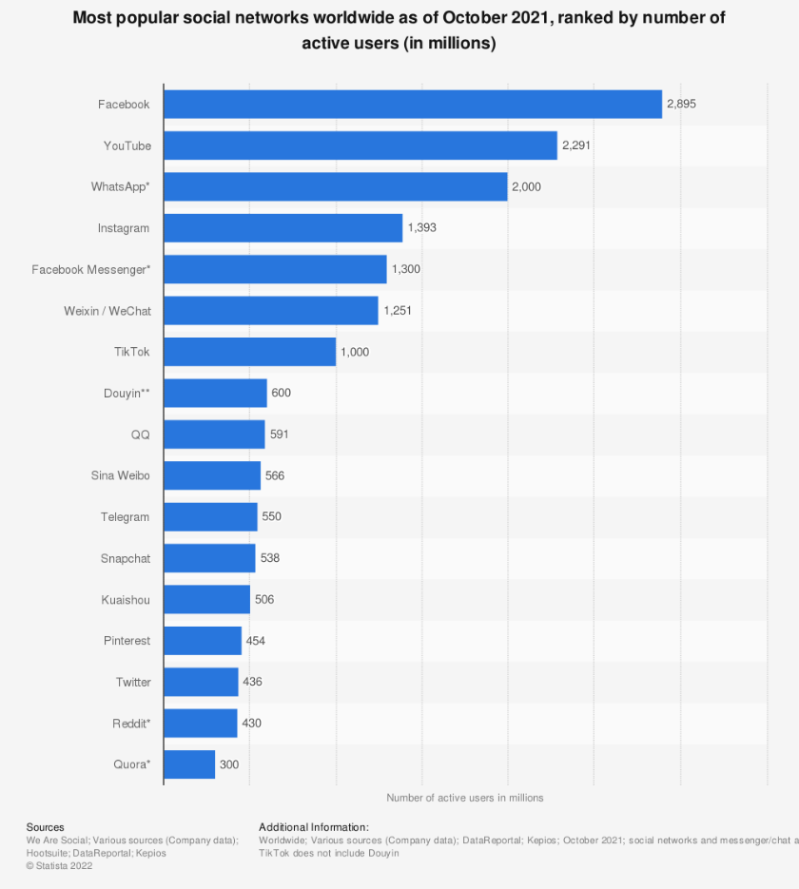 Facebook is a social media giant, remaining at the forefront of social media and is one of the most used websites, while also being the most used social media website by roughly 600 million users (Statista Research Department, 2022).

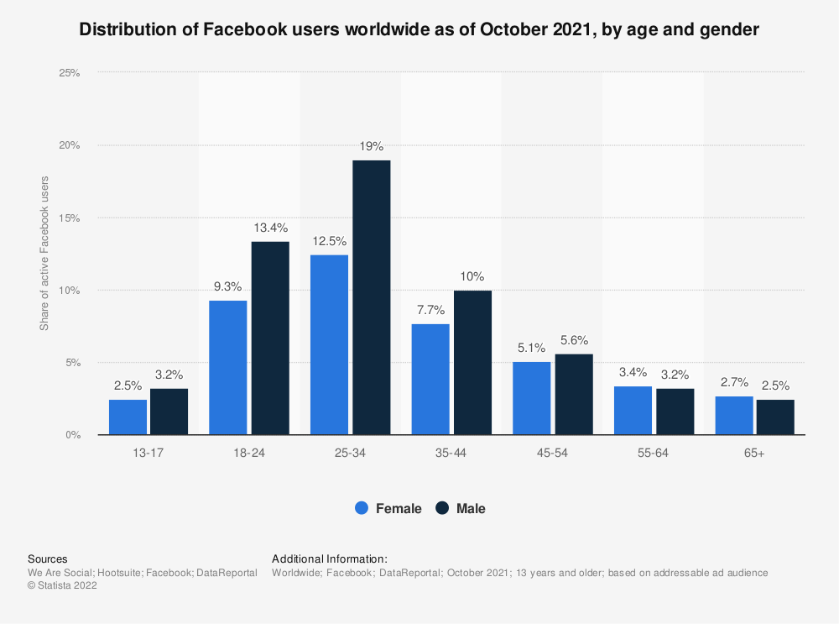Facebook, being a social media platform, its primary purpose, for users, is to allow them to connect and interact with each other online, while also allowing users to view content for different pages they might follow, post their own content and statuses, as well as small games that the website supports - this last feature is unique to Facebook. Facebooks target audience are those in their mid-20’s to mid-30’s, as this is the most active age group on Facebook by about 6% for males, and 3% for females.

When loading Facebook, users are presented with their homepage with presents users with an opportunity to browse their latest feed, upload their own statuses, and comment and like on different posts. 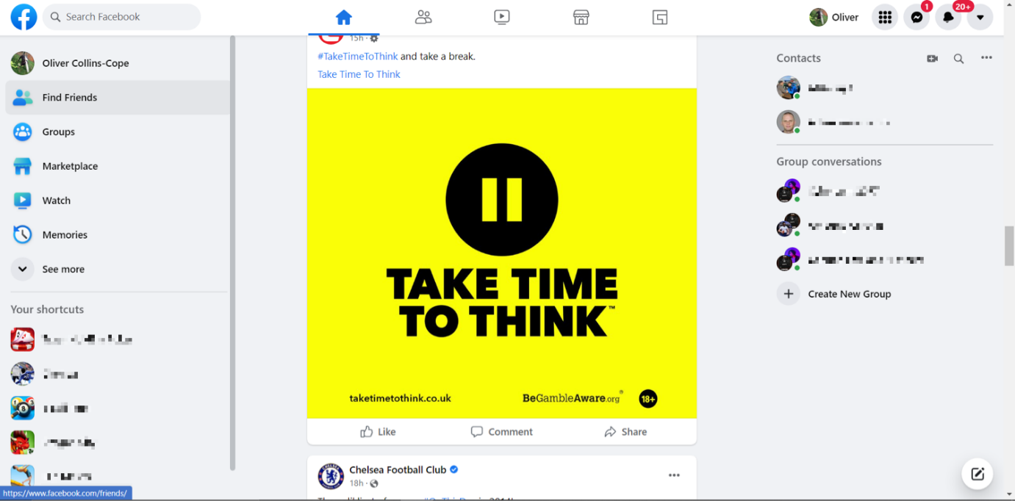

It has the option of quickly accessing chats on the right, which is convenient for the user and short cuts to different things like games on the left.

## Usability

The usability of Facebook has been highly optimised since its release in 2004, with Facebook being supported on a multitude of browsers, and available on other browsers that are not openly supported. Some examples of the browsers supported by Facebook include Google Chrome, Mozilla Firefox, Safari, and Microsoft Edge. (Facebook, 2022)

The different browsers load Facebook as shown below:

Google Chrome

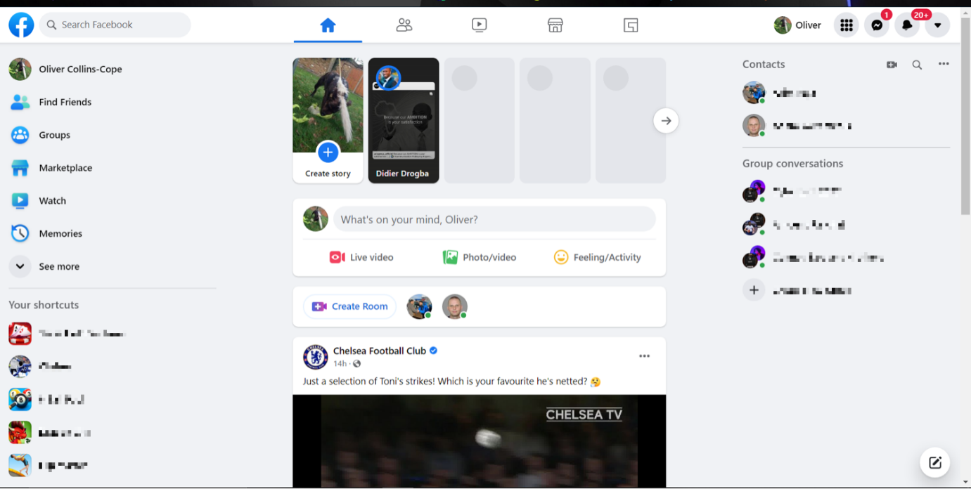

Microsoft Edge

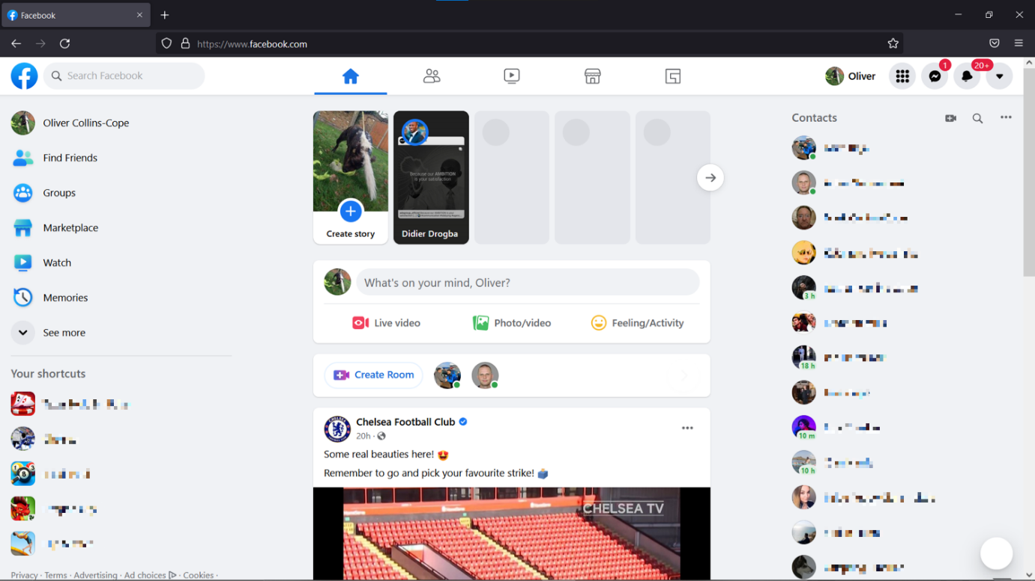

Mozilla Firefox

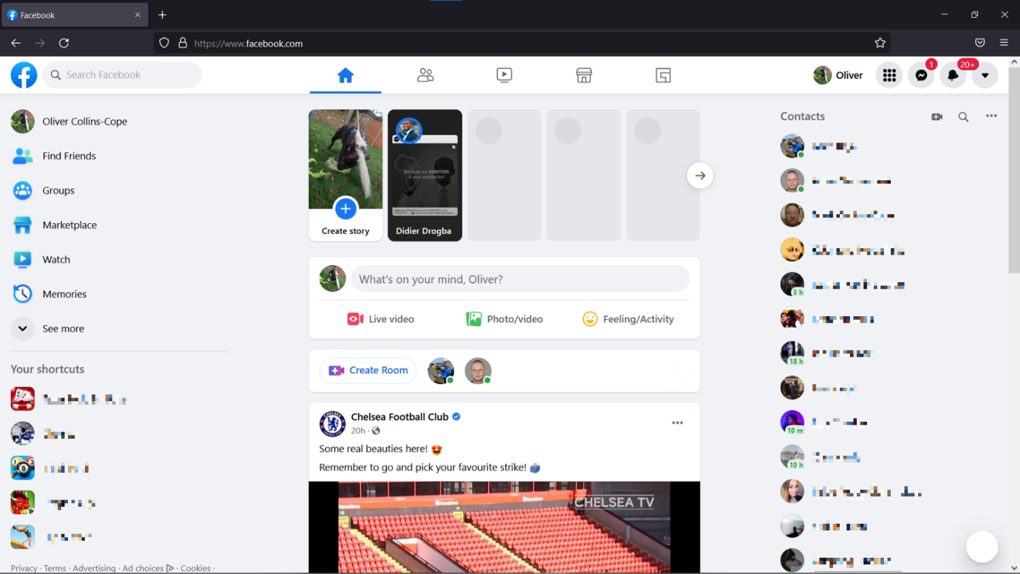

Safari

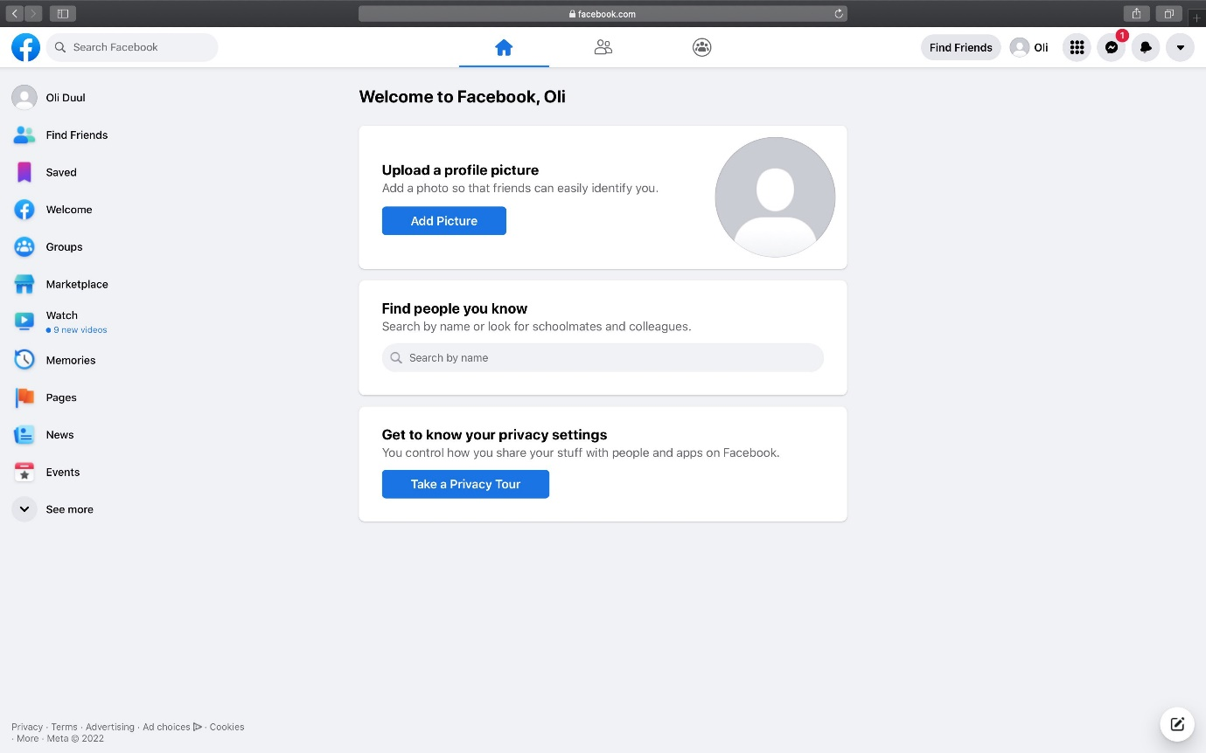

Across all the sites, they load all quickly and without an issue once the user is logged in and presents a smooth experience for the user to browse freely.

This also leads into another website design principle:

## Consistency

Across multiple browsers, Facebook remains consistent, with its design and layout remaining the same, as seen in the screenshots above. This is key as consistency in websites leads to users developing a sense of comfort and stability on the website, no matter what browser is being used.

It is important to note that the example using safari was done with an incomplete account and would otherwise load the same as all the other browsers, as seen here.

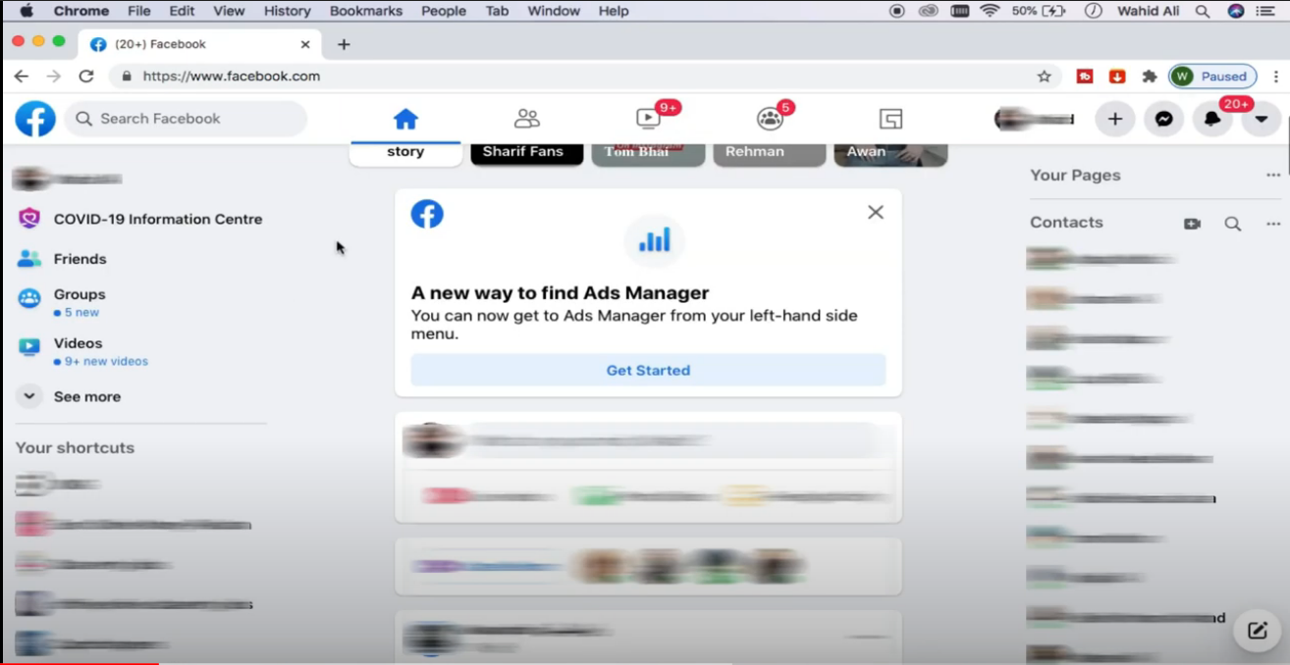

(Fix, 2022)

## Accessibility

Facebook has several accessibility options available to all users. These are made very clear to the user through a simple google search about them, upon which it brings users to a page all about the available options.

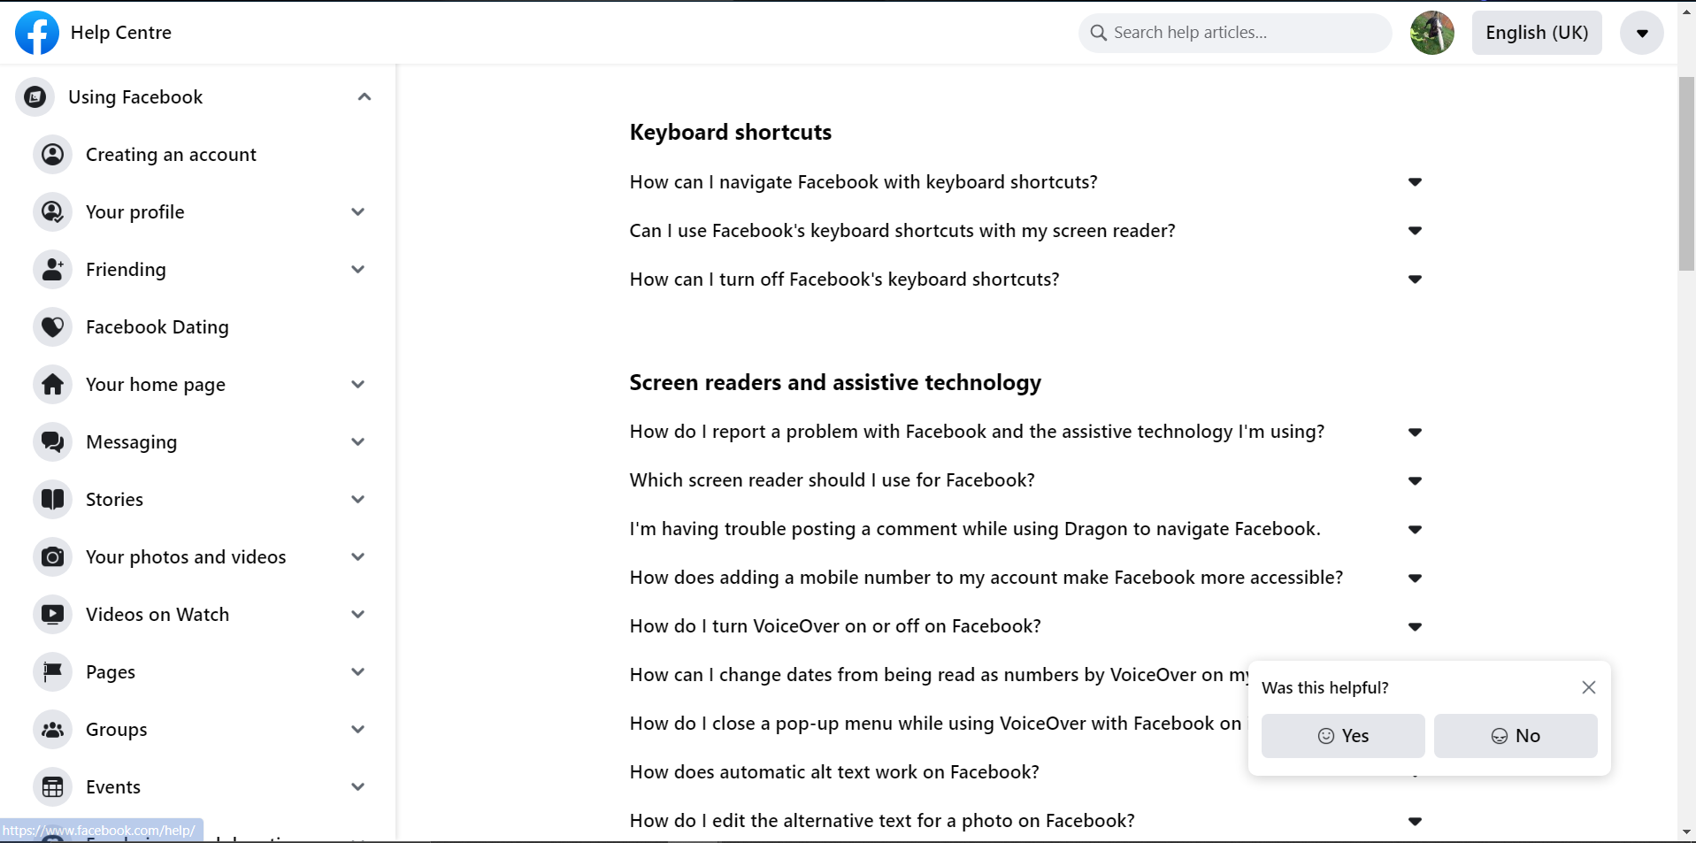

These options include:

* Keyboard shortcuts
* Screen readers
* Voiceover technology
* Closed captions (Subtitles) on videos
* Text size
* Text contrast

These options are shown as below.

Keyboard shortcuts  
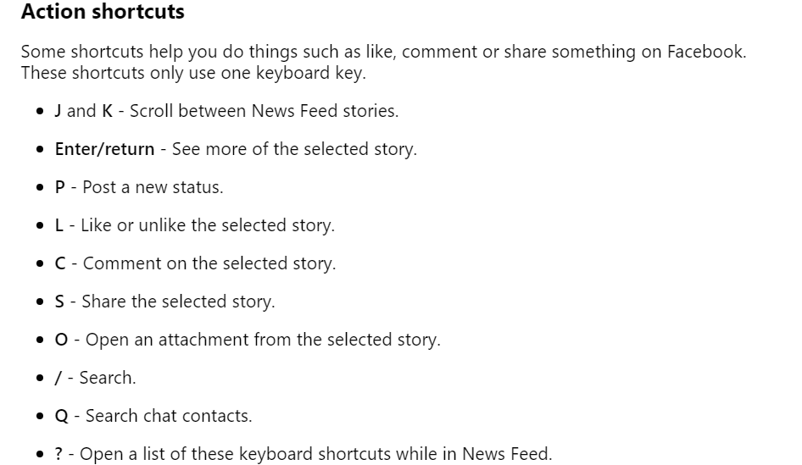

The keyboard shortcuts allow users to navigate without the use of a mouse and solely a keyboard.

Screen readers

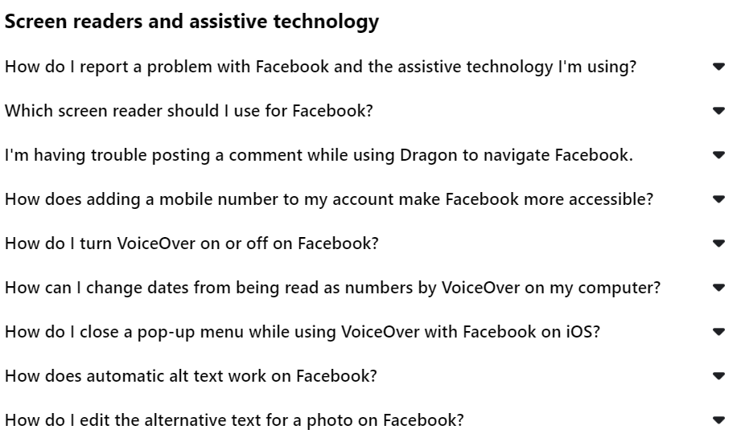

The screen readers allow for those with visual impairments that prevent them from seeing the website, navigate it and access it without the use of their eyes.

Subtitles

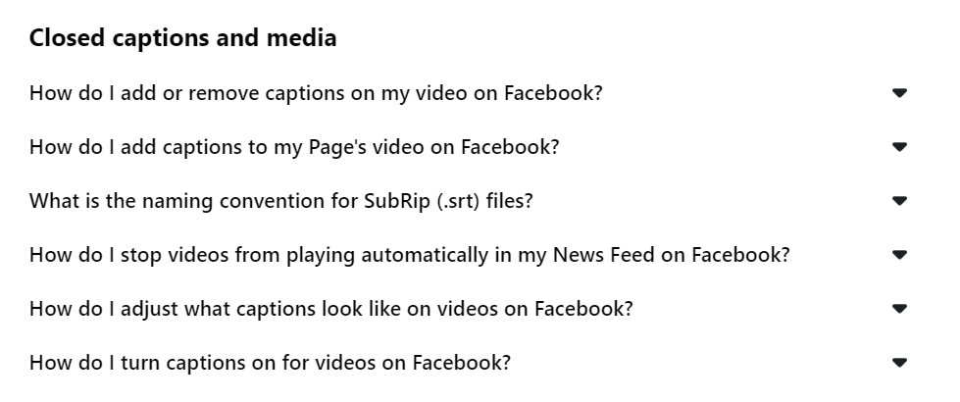

Subtitles enable users to watch videos and understand the content without having to hear or listen to them, which can greatly help users that struggle with hearing disabilities and issues.

Text size and text contrast

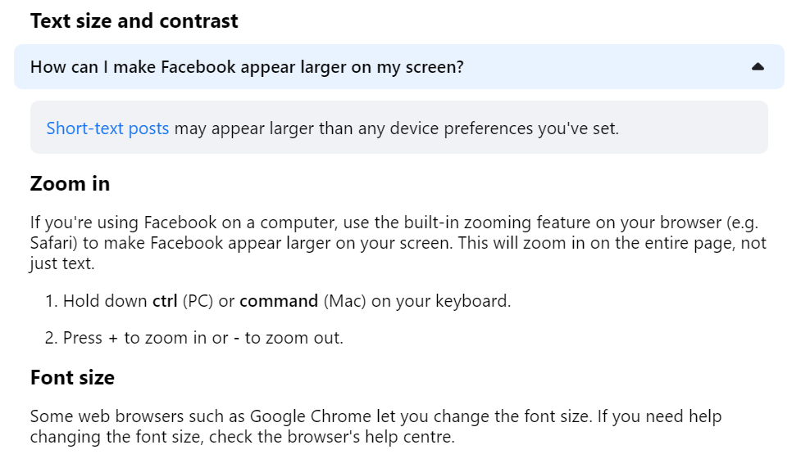

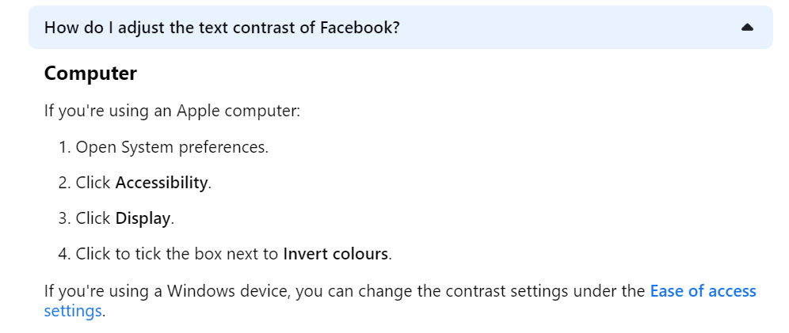

These adjustments enable users to see things more clearly that they might not have been able to see and can help users who might have issues with differentiating colours, such as those who are colour blind.

## Layout

The layout of the Facebook website remains clear and uncluttered. This is crucial as having a simpler design where the content of the website and elements of it are spread out and easy to differentiate significantly boost user experience and mean a higher chance of users coming back to reuse the site.

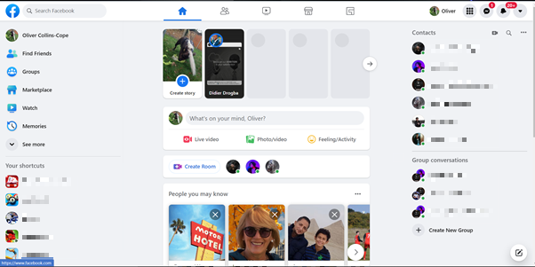

The overall layout of Facebook remains simple, with things clearly either labelled or displayed with symbols that are easy to infer and understand, like the TV screen displaying videos, and the shortcuts and contacts clearly labelled on the sides. The content of the actual home feed is clearly separated from the sides using white space, to avoid making the site look more cluttered and giving the user a more pleasant experience using the site.

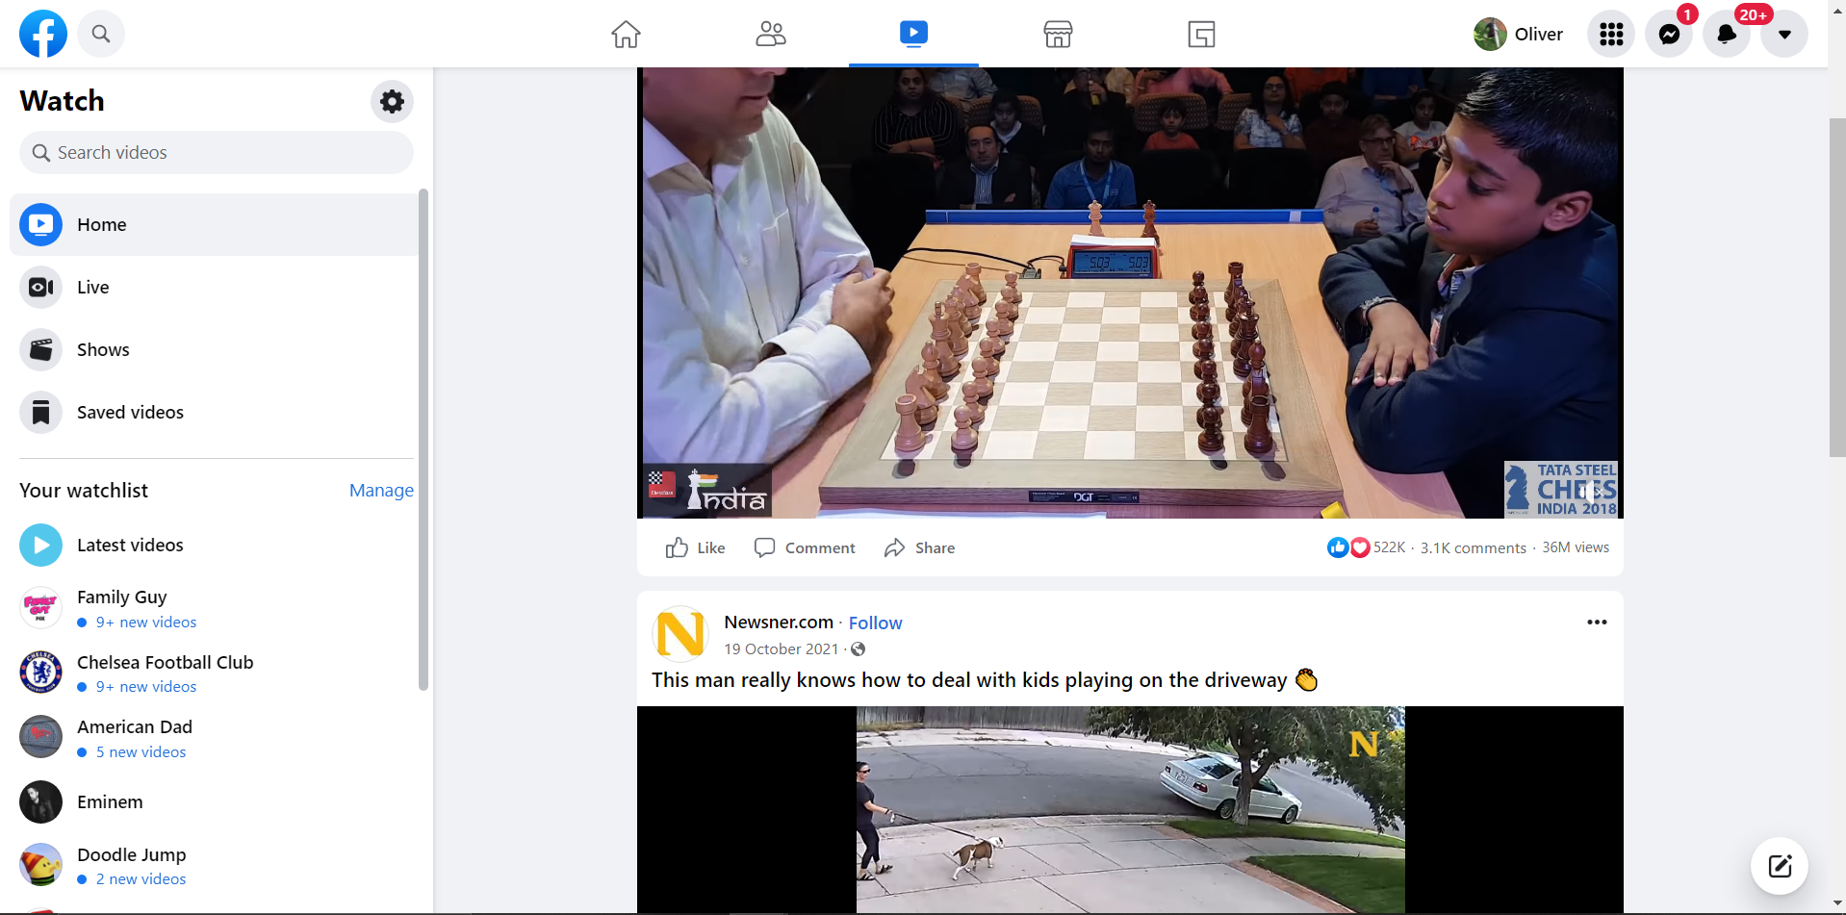

Even when switching to another tab, such as the videos side of the page, the style remains the same and the layout consistently used across it. The shortcuts on the left side remain separated from the centred media content which utilises white space for a clean and pristine appearance with a minimalistic style.

## Readability

Facebook has a clearly visible distinction between the background and any text, remaining contrasted through black and white, black and grey, or grey and white, all colours that are very easy to differentiate and Facebook makes them easy to separate from each other which allows the user to read without struggle.

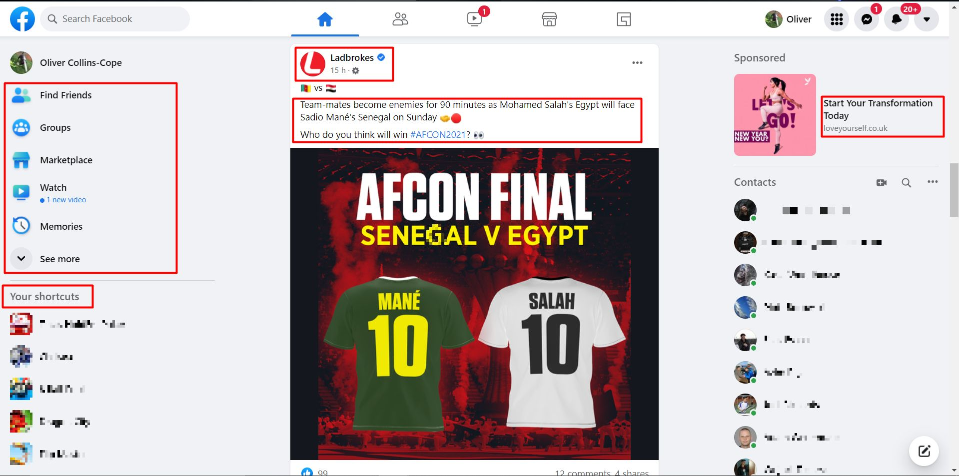

As seen in the highlighted parts of the image, there is a large contrast between the different colours of text and the background, from grey on the left and top right against grey, to the black against the white in the feed in the middle. The white of the feed also helps to separate the “white space” or rather grey space, from the actual feed and is much easier on the users’ eyes.

The font size of Facebook text is also relatively large, helping those with glasses be able to see and generally lessen the struggle of the user. In addition to this, as previously mentioned, it is possible to change the font size and type of Facebook, which can increase readability and consistency for the user.

## Navigation

Facebooks website navigation is clear and easy to see, with different tabs available at the top for the user to switch between depending on their destination, and inside of the home page, there are clearly defined sections, such as shortcuts which lead to games or specific Facebook pages, or contacts on the right – which clearly shows the different people the user has added and is able to message with just the click of a button.

This clear and simple navigation remains consistent throughout and is obvious/intuitive to the user, meaning it is very easy for the user to learn the functions and smoothly manoeuvre the website.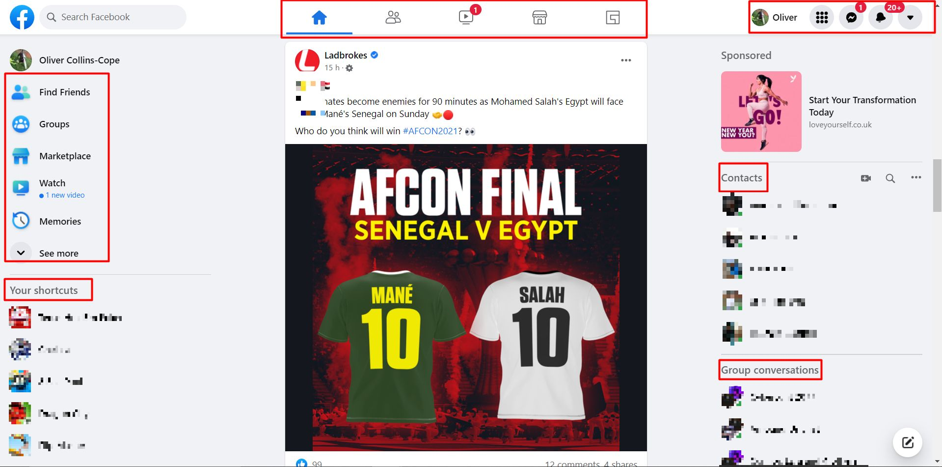

The symbols in the top right are also available for the user to use, and lead to other sections of the site, such as opening the messages, or the menu section of the site, which drops down and is accessible like that.

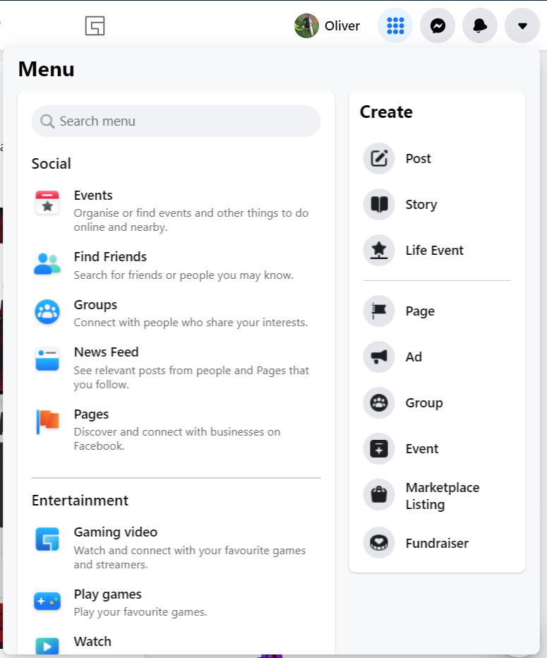

## Typography

Facebook uses “Helvetica” and “Arial” primarily.

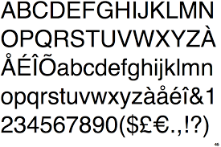

As seen above, the font style “Helvetica” is very simple and does not have any flair to it, which makes it ideal as a font for Facebook, as it will be very user friendly and accessible.

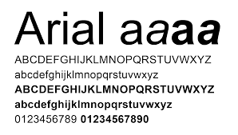

As seen above again, the font style “Arial” also fulfils the above conditions, being simple and to the point with no flair and very user friendly, even for those who struggle with other fonts.

# Twitter

Twitter is another social media website that is used by roughly 436 million users, as seen above. Although Twitter is also a social media site it differs from Facebook entirely, from its format to the way media and content is presented on the site. Throughout this section I will describe the different features using the criteria as done with Facebook, and then compare how the two differ together.

Twitter exists as a way for members to “tweet” and have their followers view their tweets and interact with them. Along with this, Twitter also allows for users to privately message each other and interact through direct messages with each other. The pages on twitter greatly vary, from news accounts such as the BBC, to content creators or political candidates, Twitters user base greatly changes depending on how it is used. Twitters primary age group, as of early 2021, is between 25 – 34, with 38.5% of the users falling into this category.

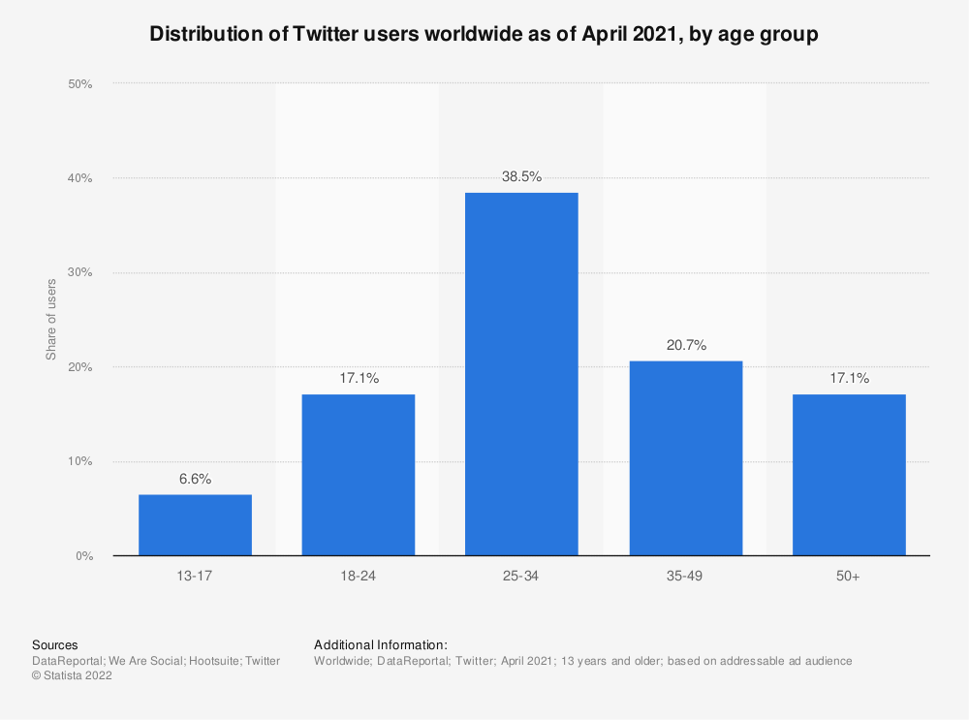

In addition to this, over 70% of Twitters audience is male, and just under 30% is female.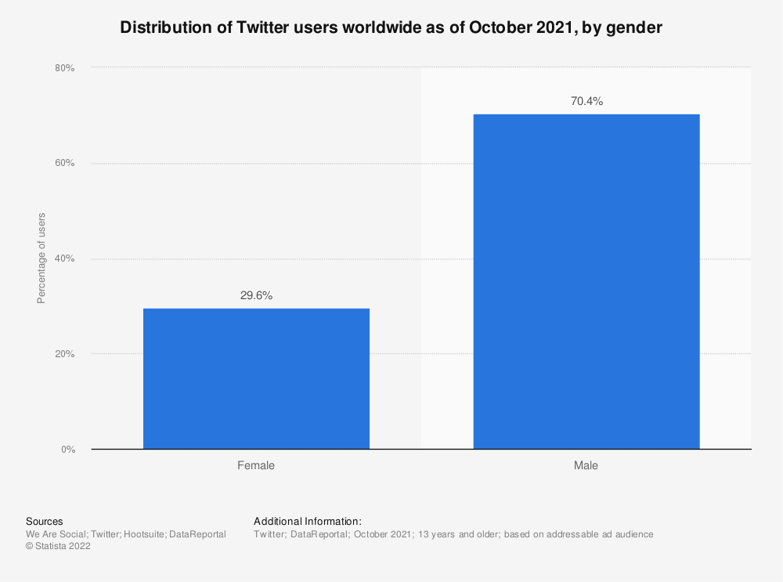

Once Twitter has opened and the user has signed in, they are presented with their home page, where they can find their feed, the option to tweet, and navigate to the different parts of Twitter, such as the different sections on the left, the search bar in the top right, the news just under the search bar which is personalised for the user, or recommendations on who to follow just under the news trends.

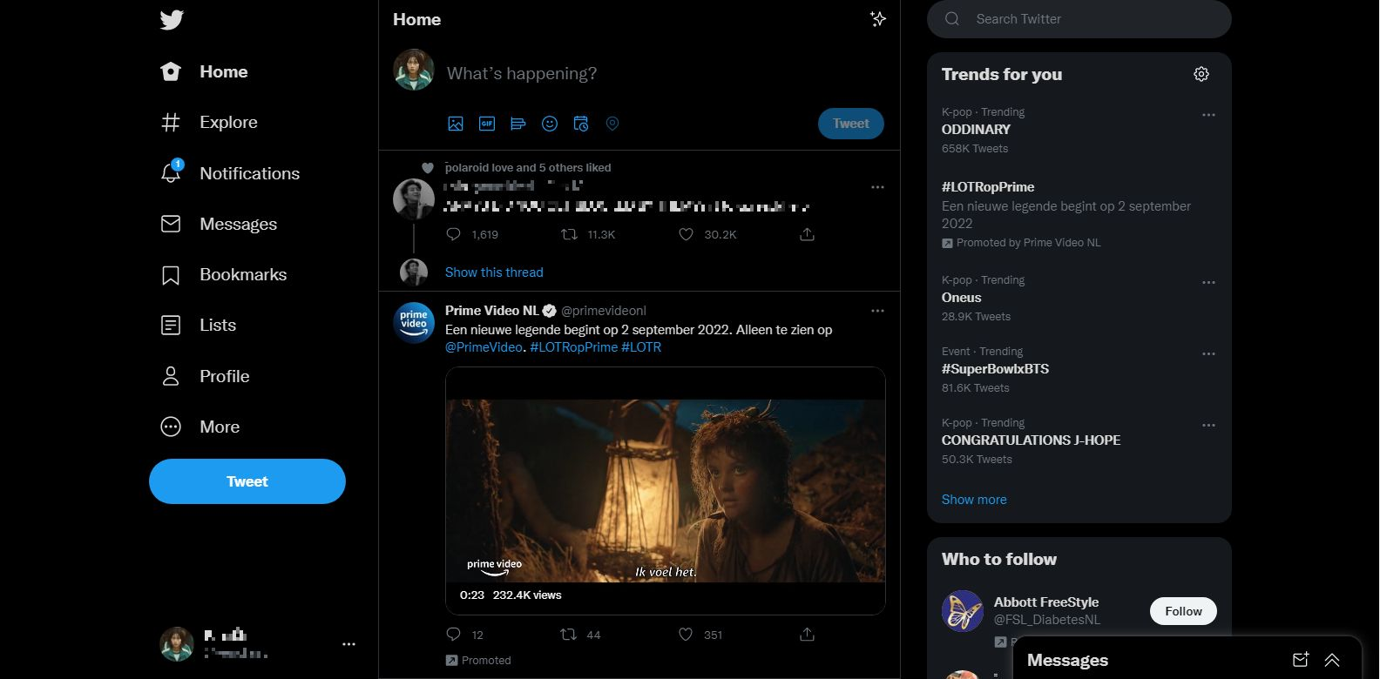

## Usability

Since Twitter was released in July of 2006 (Wikipedia, 2022) it has undergone a lot of changes in order to be supported on several different browsers and ensure stability across the different browsers. The supported browsers for Twitter are Edge, Safari, Chrome, and Firefox, and any other browser based on Webkit or Chromium engines such as Opera.

When loading on different browsers it appears as follows:

Google Chrome

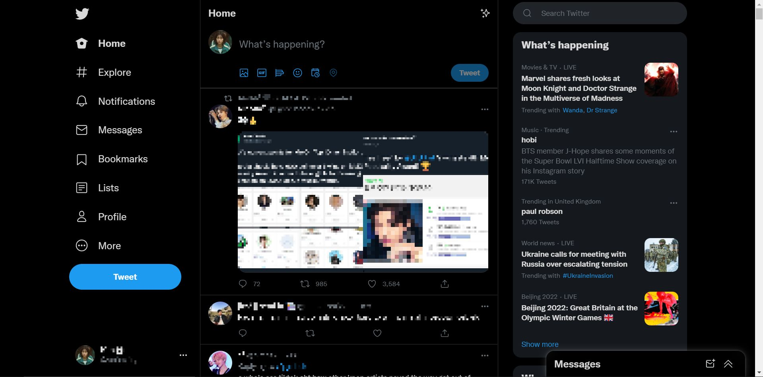

Firefox

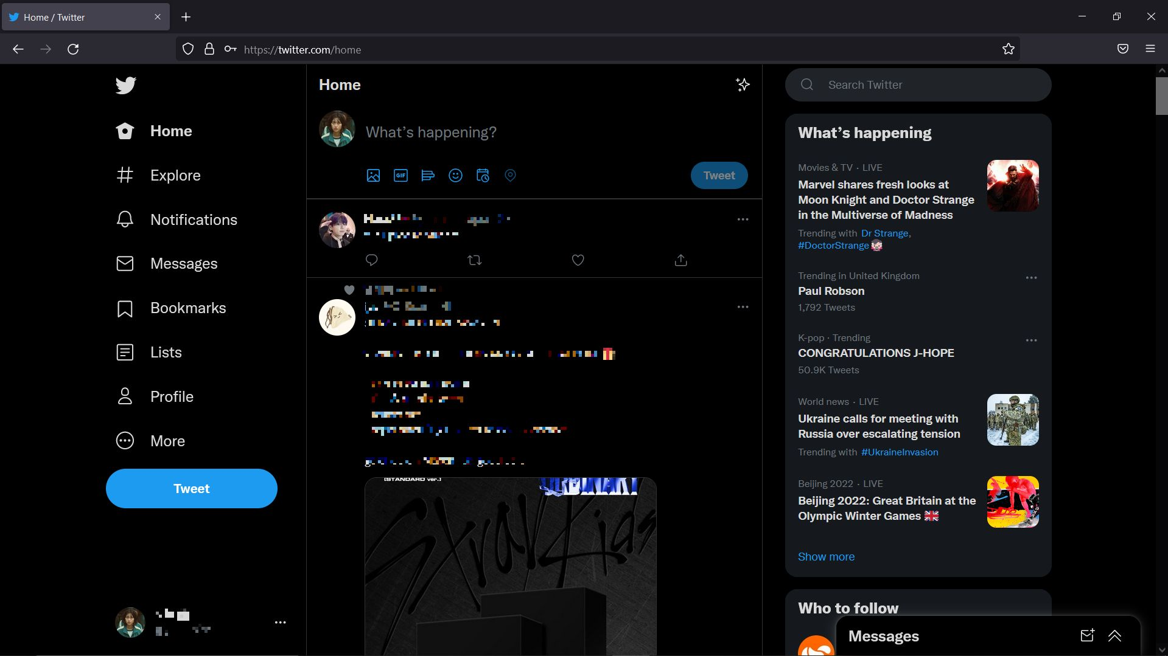

Microsoft Edge

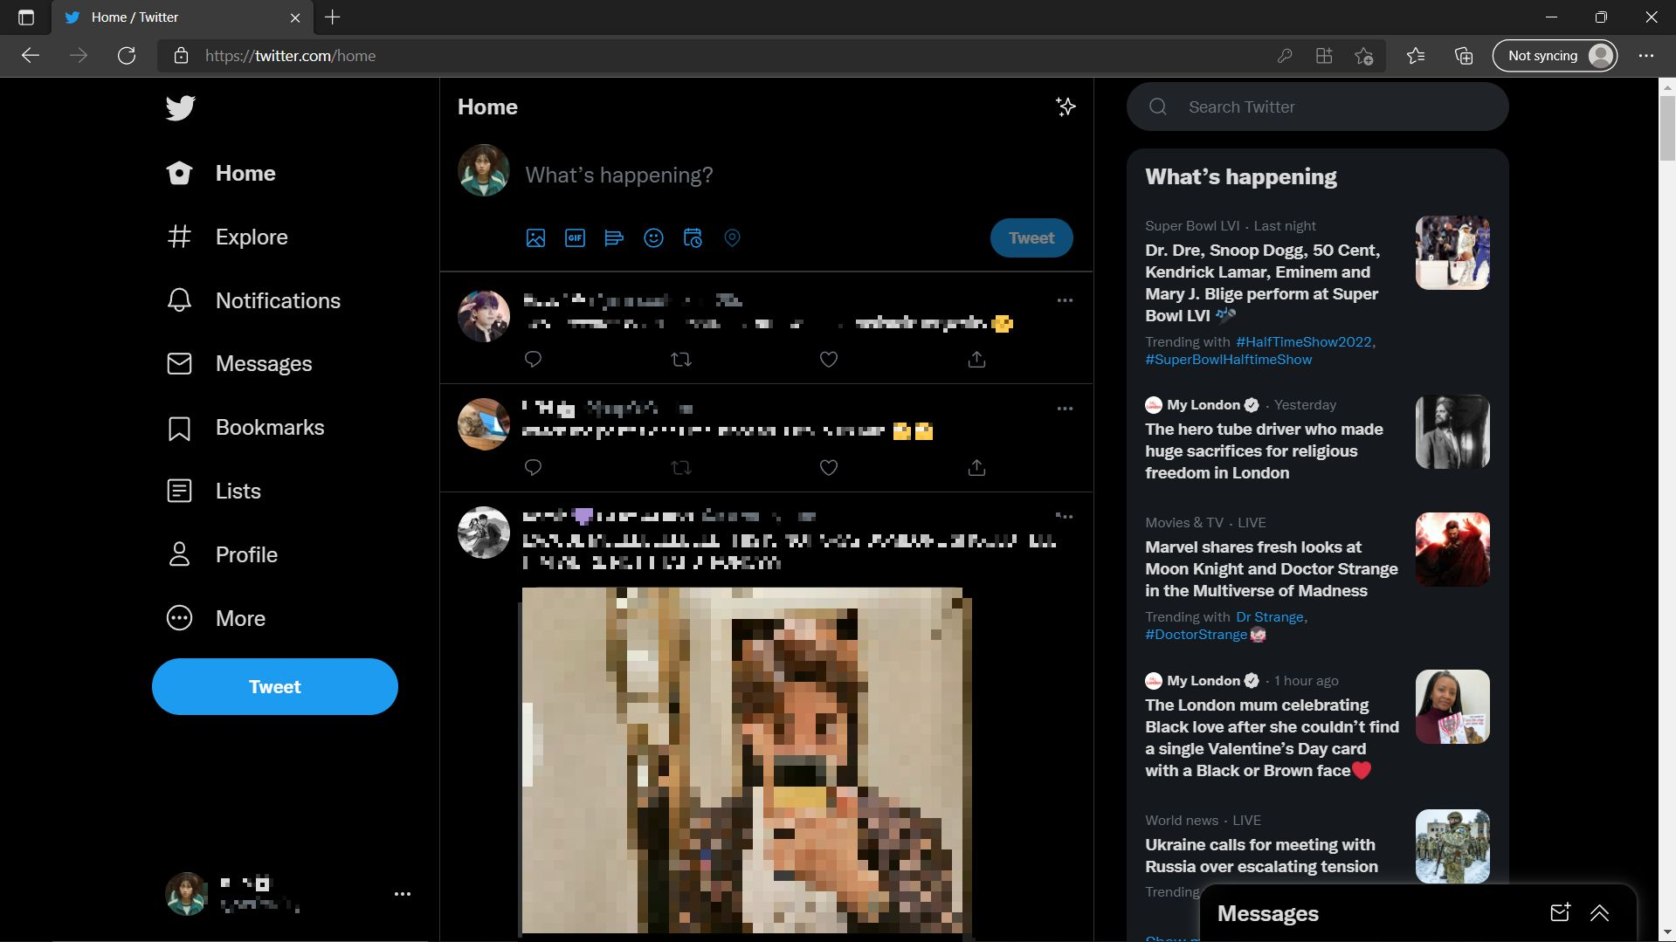

Safari

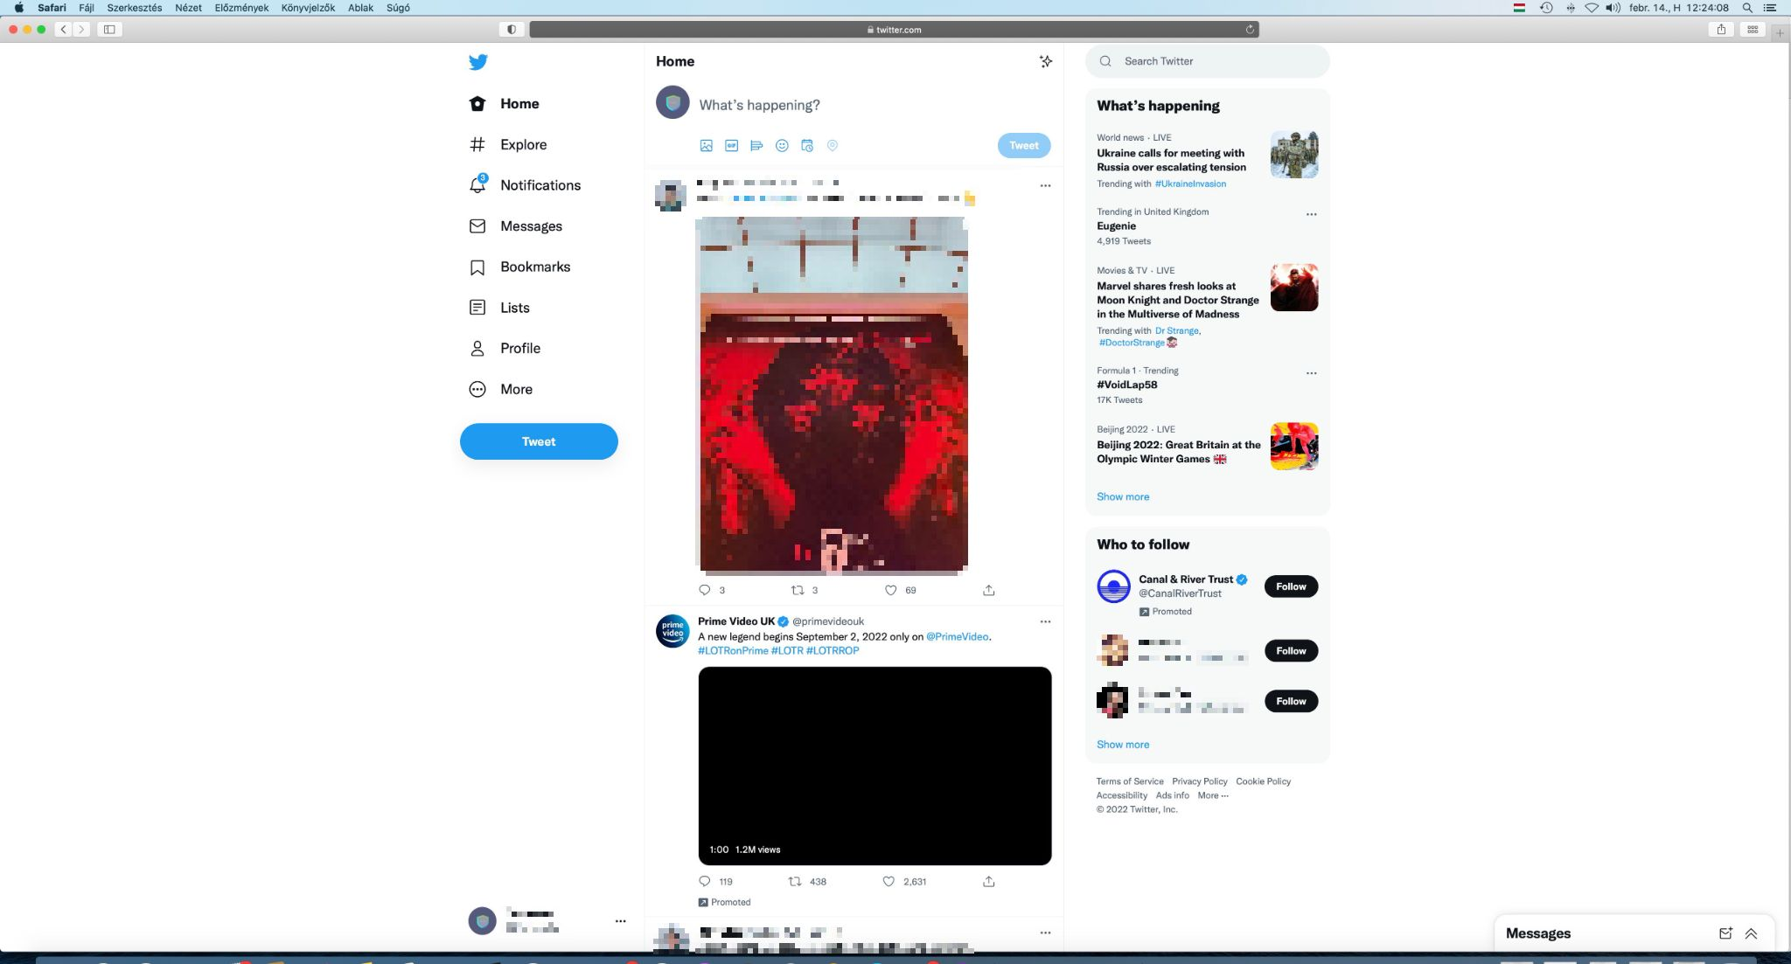

## Consistency

As shown above, Twitter also remains the same on different browser types, throughout the design and layout of the site, evidenced through the screenshots shown above. This is crucial when developing the site as this sense of familiarity gives the users flexibility to use any browsers they want and have the same experience as they might have on their primary browser.

## Accessibility

Twitter has limited accessibility options which the user can enable site wide through the settings section by clicking on the three dots at the bottom near the user’s name.

These options include:

* Visual support
* Auditory support
* Mobility support
* Cognitive support

Visual Support

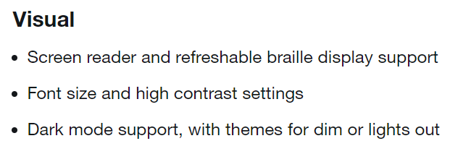

Auditory Support

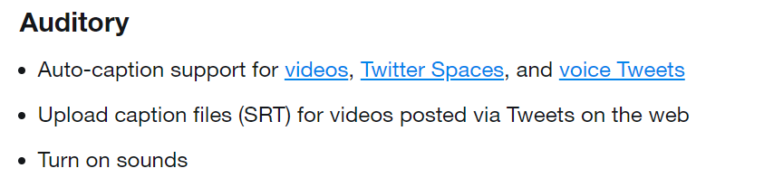

Mobility Support

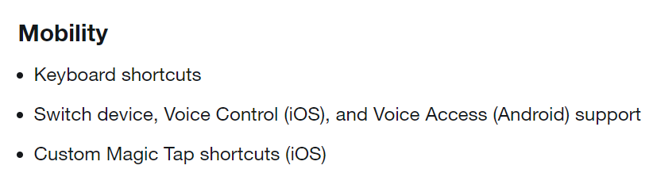

Cognitive support

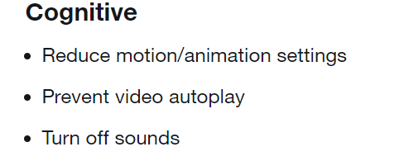

## Layout

Twitter effectively and efficiently spaces out the different parts of its page in order to not clutter everything together and create a nice balance between content and empty “white” space. As seen below, there is plenty of space throughout the page, even a gap between the “What’s happening” section and the “Who to follow” – which is slightly obscured – in order to clearly separate the two, but still make the most of all the space on the page.

The feed section in the centre of the page is clearly separated using greyed out lines to differ between what belongs to the section on the left, and the columns on the right. This white space effectively divides the page into different parts and allows for a cleaner look overall for the user.

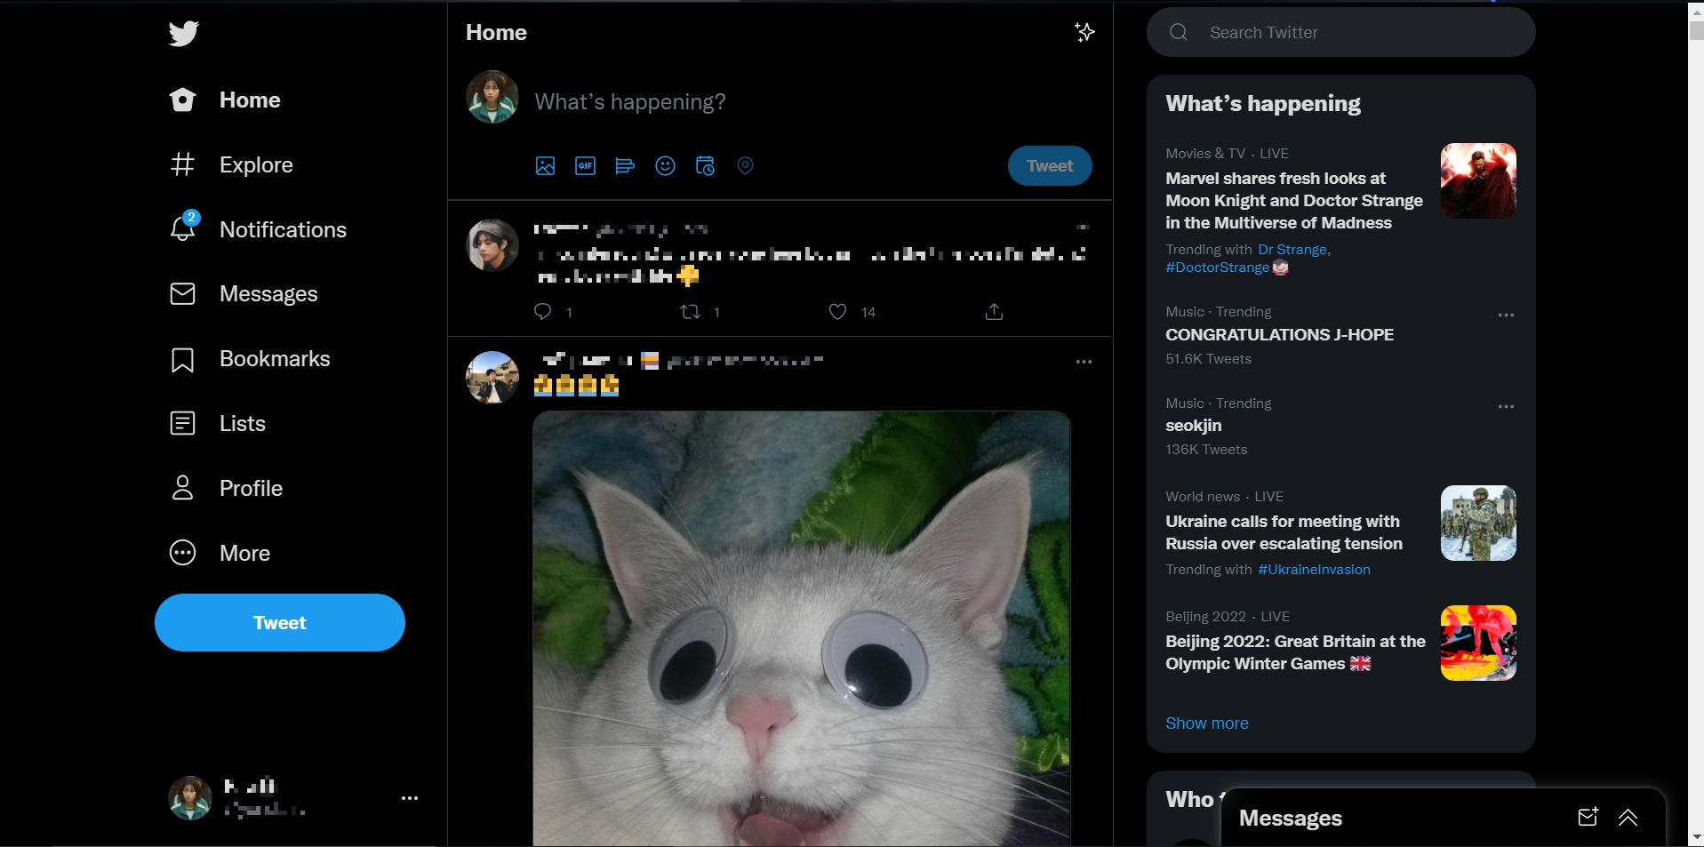

## Readability

The content on Twitter is easily readable and very clearly separated from the background. This is done through the contrasting colours of the text and the background, whether it is a black background or a white one, the text changes colour accordingly and is therefore very recognisable.

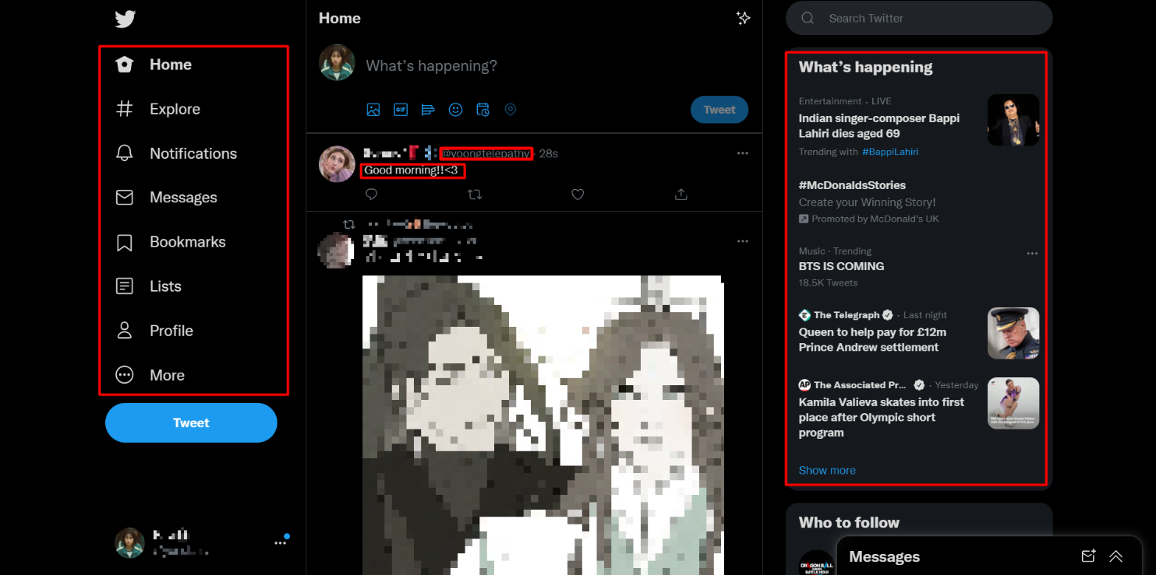

As shown, the text in the screenshot is clearly visible from everything else. On the right side inside the box, the text also has a different background to the normal feed, which helps to separate the different sections, with the help of white space.  
The greyed-out text of the users Twitter handle also helps the user to figure out what is the accounts username and “Twitter @”.

## Navigation

The navigation of Twitter is very simple and intuitive. While most of the site remains on the home page where the user opens on, they have the option of the search in the top right, as well as the buttons on the left to go to the relevant section. These parts are clearly separated from others, and even generate a hover feature that shows the user what they are hovering on and clearly giving them the option to click on it.

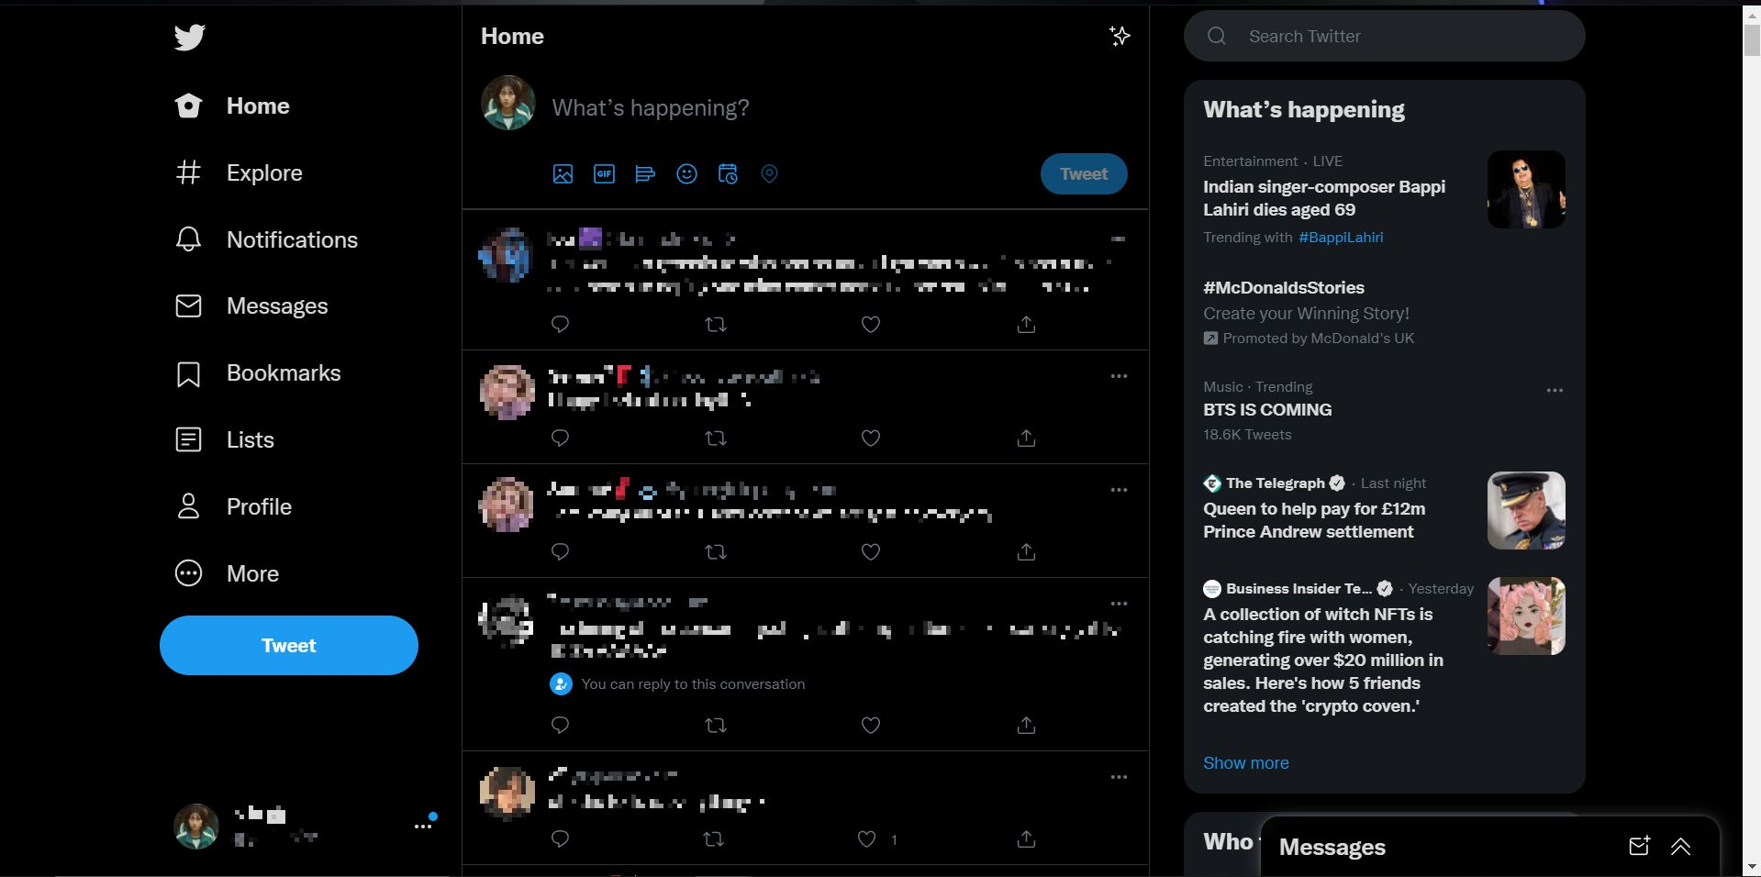

## Typography

Twitter, like Facebook, uses Helvetica  
  
This makes it easy to see the text and the characters are very familiar to users, which helps to bring users back to the site.

# Media and Content

Content refers to the content of the website including text, graphics, as well as other media and other interactive elements and objects. It is important that any content used is consistent across the website even when going to different tabs and subsites, and any content that the user did not personally create or buy the rights for, must ensure that they have permission for the content that they use within their site.

Media regards things like interactive content, including videos, background sounds, flash images, and miniature applications within the site. These different elements are used within the site in order to divide the site and entertain the user, improving their experience in the site. However, it is critical to consider the fact that too much media can overwhelm the user and clutter the website, as a result of that that can lead to increased loading times and less user interaction with the site.

Media  
Some important factors to consider when using media include;

Position – Such as where the media object is placed. This must be placed in a location where it can get the attention of the user however not obstruct any other part of the site.  
Colour – Is important to consider as colour plays an integrate part when creating your website. Factors such as too many colours or conditions such as epilepsy and photo sensitivity are unable to use sites that abuse vibrant colours and is therefore important to keep track of.  
Size – It is also important to consider size. This is because screen size is an important factor to consider when developing your website, as websites are often used on different size screens such as monitors, laptops, tablets, and phones, and therefore if embedded videos and media content is too large and take up most of the screen, it will influence the rest of the content. One result of this is that other content within the site might be inaccessible or unreadable due to formatting.  
Practicality – Finally it is also important to consider whether the media and content that is being used is appropriate within the site. This is because any media or content in the site will always increase loading times, which may lead to users being frustrated with the sites delays in loading.

Some examples of Media types used by Facebook and Twitter include:

Videos  
Images  
Gifs

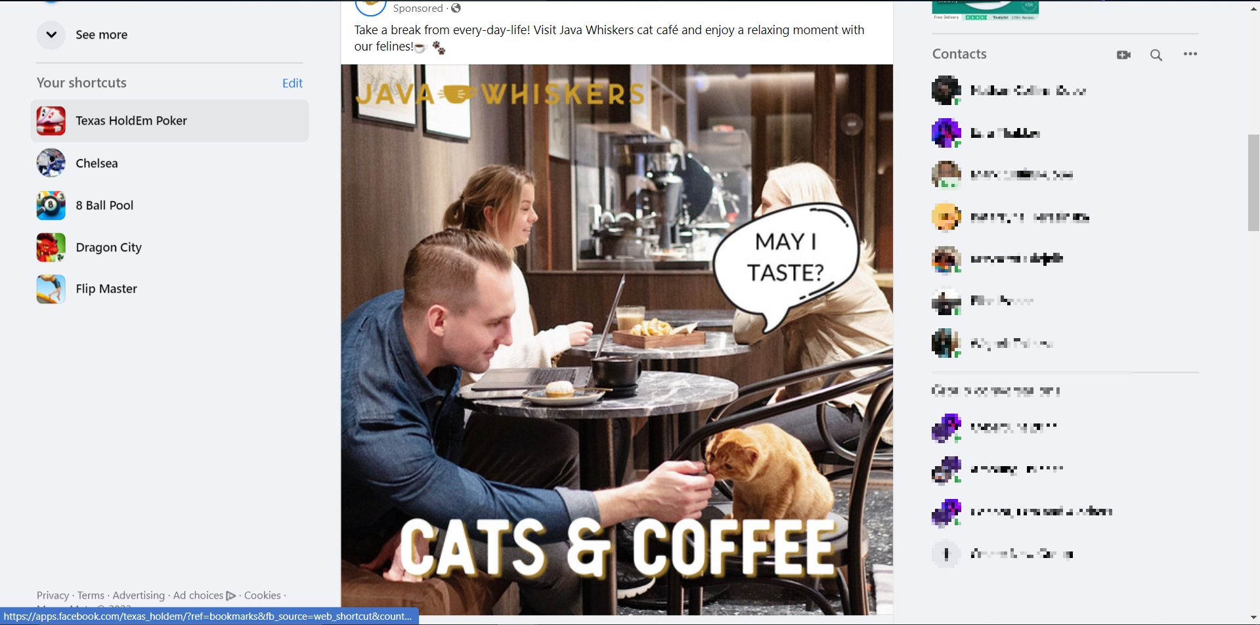



Image

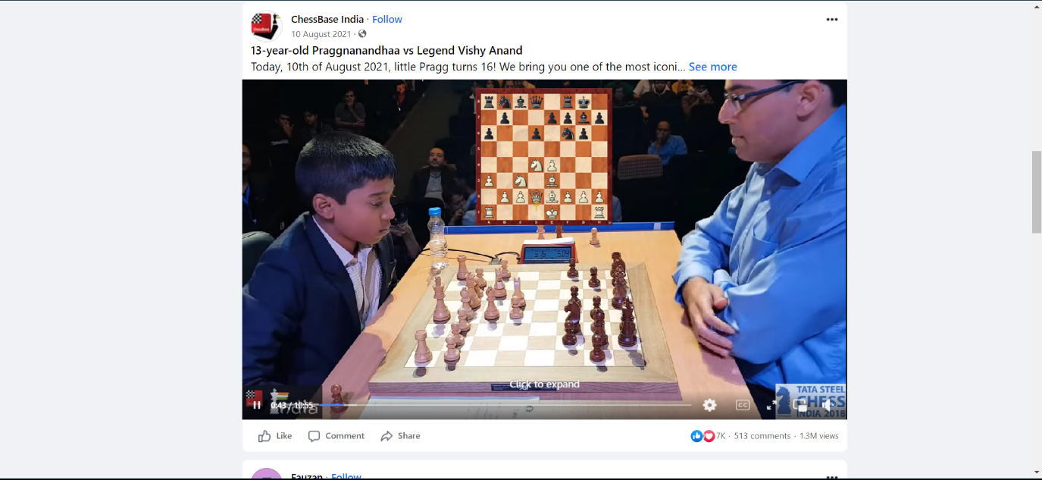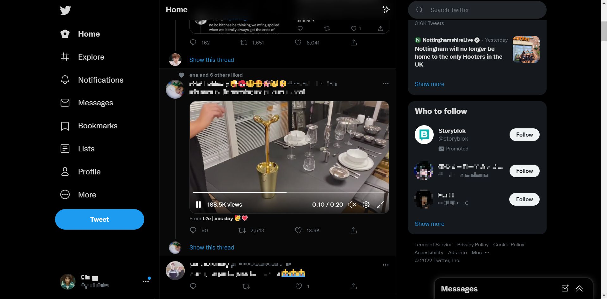

Video

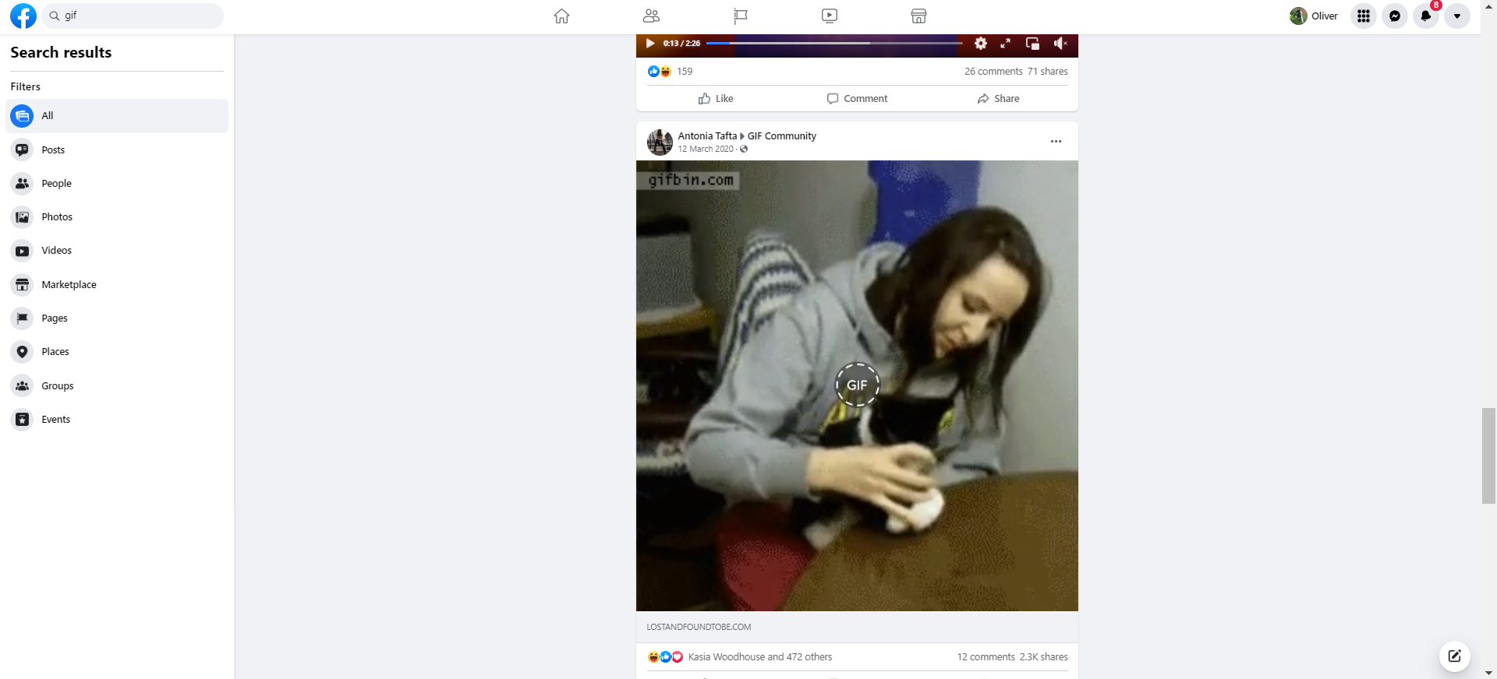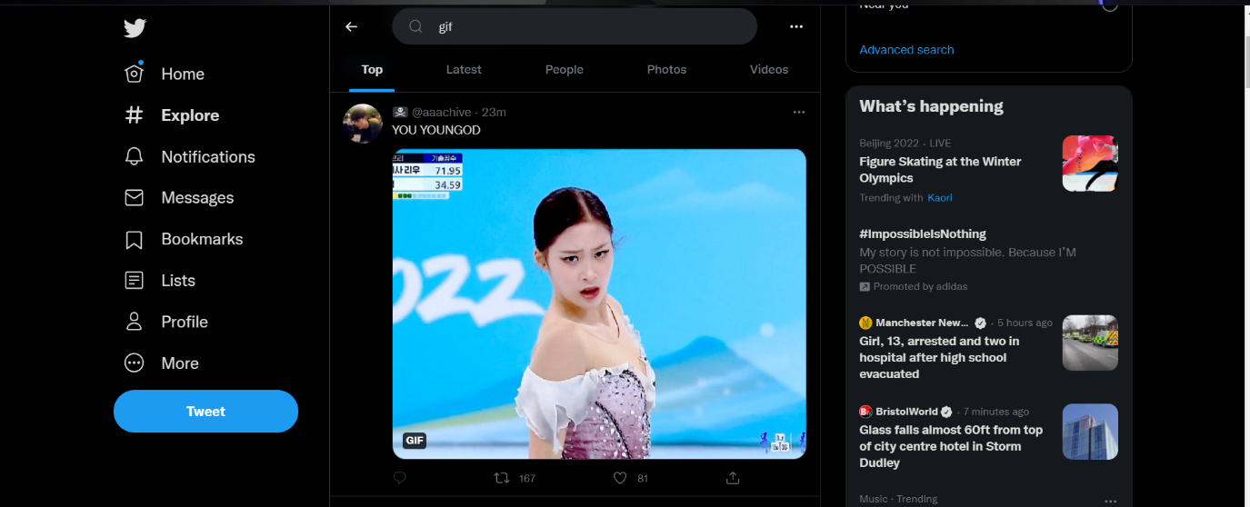

Gif

Twitter uses media and content effectively while following the criteria as listed above. This is evidenced through the fact that the position of the media is always central to the page staying consistent and minimising the need for change across different devices. Furthermore, the colour scheme stays consistent across the page depending on which setting user selected for the site, which gives the user a variety of options depending on their needs and preferences.

Facebook also uses media and content effectively, with the media being spread out throughout the site on the user having the option to select different parts of the site to use in order to view the media. Furthermore, the colour scheme of Facebook is dull and simple, so as not to risk affecting anyone.

# Comparison

## Usability

Both Twitter and Facebook have been optimised since there at least in order to ensure the website is very user friendly. One example of this is how both sites load on all browsers, and furthermore remain consistent across those browsers giving uses the same experience no matter what browser they're using to access the website.

## Consistency

As previously mentioned, and evidenced above in the separate sections for Facebook and Twitter, the consistency across Facebook and Twitter remains first rate as the sites consistently load the same no matter what browser is being used. Furthermore, when navigating different parts of the website Facebook and Twitter both remain consistent in their design and display.

## Accessibility

When it comes to accessibility, Facebook appears to be far friendlier to those who require additional support, as Facebook open the presents these options not hidden away under different subsections. However, upon further inspection Twitter also presents the same options to the user such as text size and contrast changes. Both sites provide valuable instructions on how to use these different accessibility features, ensuring all users have a fair experience on their website.

## Layout

The layout of both sites takes care to ensure that the site will not be cluttered and compact. The primary difference between Facebook and Twitter, is that while on Facebook there are multiple different tabs for different parts of the site such as watching videos and the homepage, on Twitter this is all found on the homepage with the other sections being limited to things relevant to the account such as profile, lists, messages, notifications etcetera. This results in Twitter having a simple design as opposed to Facebook with utilises multiple tabs and various pages for the different parts of the website.

Both websites successfully execute a smooth layout which leads to an enhanced experience for the user and increases user satisfaction.

## Readability

The readability of Facebook and Twitter does not change much between the two sites. Both websites ensure the whenever there is text the background is clearly separate, as evidenced in the screenshots above. Facebook and Twitter also both use different colours of text in order to differ from different types of information, such as username handles and post times. Furthermore, they ensure that all the text relevant to that site is easy to understand and simplified so that there is no need for further assistance in order to understand it. Some examples of this include instructions on how to apply different size text and contrasting colours.

## Navigation

As evidenced throughout the screenshots in this paper, the navigation of both websites remains fluid and intuitive. While Facebook utilizers tabs at the top of the screen, Twitter on the other hand has options available on the sides, showing off the design difference between the two websites. Both sites also have clear components which make it obvious where the user can navigate to different sections of the website.

## Typography

The typography of both sides is very consistent with both using Helvetica. This allows for consistent experience for the users and a familiar font, meaning that the users who have the same experience regardless of what site they are on.

# Performance

There are several factors that affect performance of a website. It is important to consider all of these when designing a website in order to ensure that no matter what situations occur, the website will run smoothly and efficiently.

These factors include:

* Scripts
* Browser compliance
* Server-side factors
* Client-side factors

## Scripts

A script is a sequence of instructions that is carried out by another program other than a computer processor. Scripts are commonly used to generate web pages and automate computer processes and change how the website behaves in response to certain click requests which are sent by the user.

### Server-side

Server-side scripts are used for more advanced features such as verifying login credentials by connecting to a database or recording transactions on online businesses. This works through a user requesting a web page from the server, from which the script in the page is processed by the server in order to suit the needs of the request and sends it to the device.

One downside of server-side scripting is that when a user makes request over the network it can slow downloading times and put excess strain on the server.

### Client-side

On the other hand, client-side scripts are executed through the user device. Client-side scripts can be useful as they help provide extra interactivity in different web pages such as customisation, dynamic content, image carousels, and slide shows without the downside of having to connect to the web server.

## Browser compliance

As previously discussed in the usability section of each individual website,

# Bibliography

Facebook. (n.d.).

Facebook. (2022, February 3). *Facebook*. Retrieved from Facebook: https://www.facebook.com/help/210310575676558

Facebook. (2022, February 3). *Facebook*. Retrieved from Facebook: https://www.facebook.com/help/273947702950567

Fix, T. (2022, February 3). *Youtube*. Retrieved from Youtube: https://www.youtube.com/watch?v=poRAttiNWYo

Statista Research Department. (2022). *Statista*. Retrieved February 1, 2022, from https://www.statista.com/statistics/272014/global-social-networks-ranked-by-number-of-users/